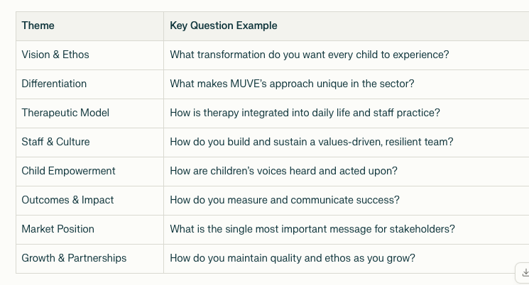

Submitted content assessment:

1. A journey where we transform crisis to (positive ‘c’ word) – understanding that their voice matters)
   1. Best possible outcome for children raised like this.
   2. Working with social workers, head of services, director of children’s services B2B
2. MUVE – regulated field – we need to be very mindful about
   1. Avoid the words – registered, regulated, board-approved (nothing like that)
   2. Call it a therapeutic home – not a clinical therapy
   3. My life, my voice! (beautiful)
3. Therapeutic model:
   1. In-house psychologist – should be looking into this
   2. How we understand ACE & trauma on children, and impact on cognitive, emotional and psychological development
   3. Understand attachment styles
4. (5, actually) each child is involved in:
   1. Flexible transition plan – individually tailored and child-led
   2. Take away pressure by doing video
   3. Meeting a child in their own environment and how they’re engaging with people around them
   4. Keep one consistent carer – they should have met everyone on that team (know everyone’s face and know everyone’s name)
   5. Children’s guide has to be child-friendly (no huge pieces of information, and a lot of visuals)
5. Care plans, weekly reports & psychological reports:
   1. Tracking milestones and achievements
   2. Not doing learning disabilities
   3. (SEMH – google this)
   4. Each individual child, and tailor each according to Maslow’s hierarchy of needs (can’t move to the second without moving through the first)
6. B2B
   1. Can we deliver high quality of care
   2. Working in partnership – can our work impact their 5 year strategic plan to achieve
   3. Department of Children’s Service – Birmingham
7. Sit on the judging panels for:
   1. Sponsor certain awards – making badges and CYP badges, promote that we’re the sponsors
   2. Nominations
   3. University of East London – vocational educational funded
   4. Youth-working degree – first intake for London
   5. Cohort – first providers outside of London (all our staff members will have a fully funded youth-working degree)
   6. Nurturing Steps

Action items:

1. Therapeutic model of care -